acute deteriorating

patient SEMINAR

Dates:
28 – 29th May 2024 - Toowoomba
Time: 8:30am – 3:30pm
Cost: $550
Payment plans available
CPD: 13
presented by Rob Timmings

Two-day seminar – fully catered

The ECT4Health Acute Deteriorating Patient Seminar is a two-day program which overviews the assessment and management of patients with a range of presentations that represent acute deterioration. Throughout the seminar we discuss physiology, assessment and management of patients with surgical and medical problems.

It is inevitable that we care for people who deteriorate, nurses need to be a step ahead and recognise the subtle signs of deterioration. This seminar is jam packed with so much that you’ll wonder why you didn’t do it earlier!

Content includes:
- Patient assessment – in trauma
- Sepsis and fever recognition
- Hypoxia and respiratory failure, asthma and pneumonia
- Altered levels of conscious, GCS, hypoglycaemia and strokes
- Shock and the different types, and management

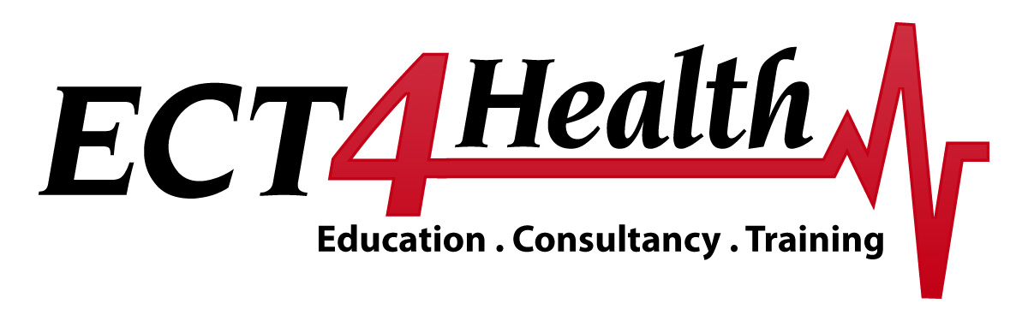

Acute Deteriorating Patient Seminar

Times | Day One
8:30 | Introduction – house keeping
8:45 | Basic physiological overview
10:00 – 10:15 Morning Tea
10:15 | What is Hypoxia? Respiration and respiratory failure
11:00 | Cardiac anatomy and physiology overview
12.00 – 12:30 Lunch
12:30 | Interpreting the Lead II cardiac Rhythms - theory
13:30 | Interpreting the Lead II cardiac Rhythms - practical
15:30 | Finish

Times | Day Two
8:30 | Assessing chest pain
9:30 | Primary and Secondary Assessment - Trauma
10:30 – 10:45 Morning Tea
10:45 | Paediatric Assessment – What is a sick child?
11:15 | Sepsis and fever recognition
12.00 – 12:30 Lunch
12:30 | Shock – types, symptoms and management
13:30 | Altered levels of consciousness – causes and measuring GCS
14:30 | Respiratory presentations – Asthma and Pneumonia
15:30 | Finish

N.B. Please note that this timetable is indicative only and is subject to change.

